Concert Booking

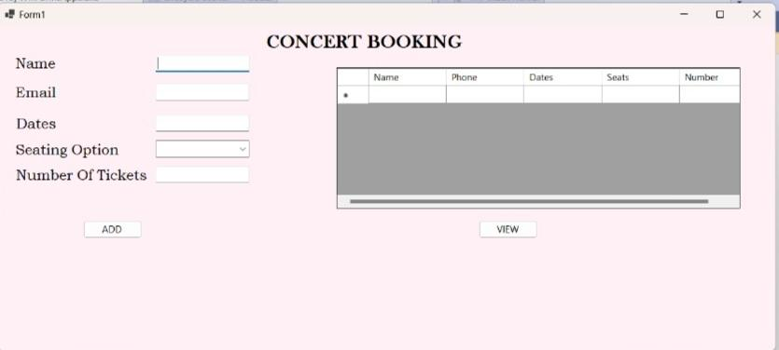

Aastha Kushwah 145

Siddhi Prabhu 148

TYBCA1

BATCH3

# 

# 

# 

# OVERVIEW

# The Concert Booking System is a comprehensive C# application developed on the .NET Framework. This system provides an intuitive and user-friendly interface for concert-goers to browse available dates, select seating preferences, and book tickets. Built with a focus on simplicity and efficiency, this system streamlines the concert booking process for users and ensures smooth event management for organizers.

# FORM IMAGES

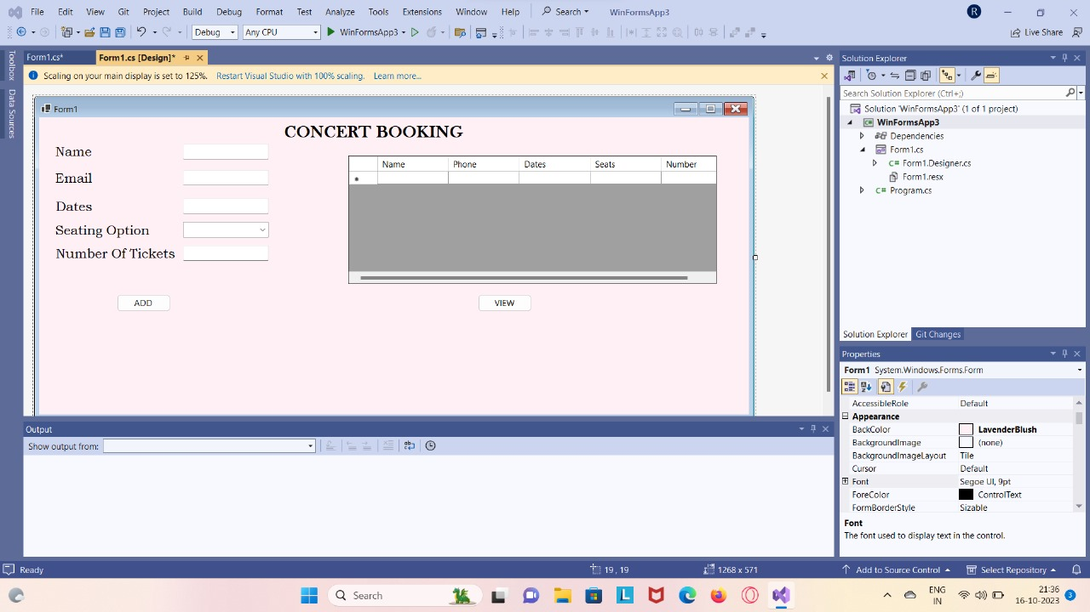

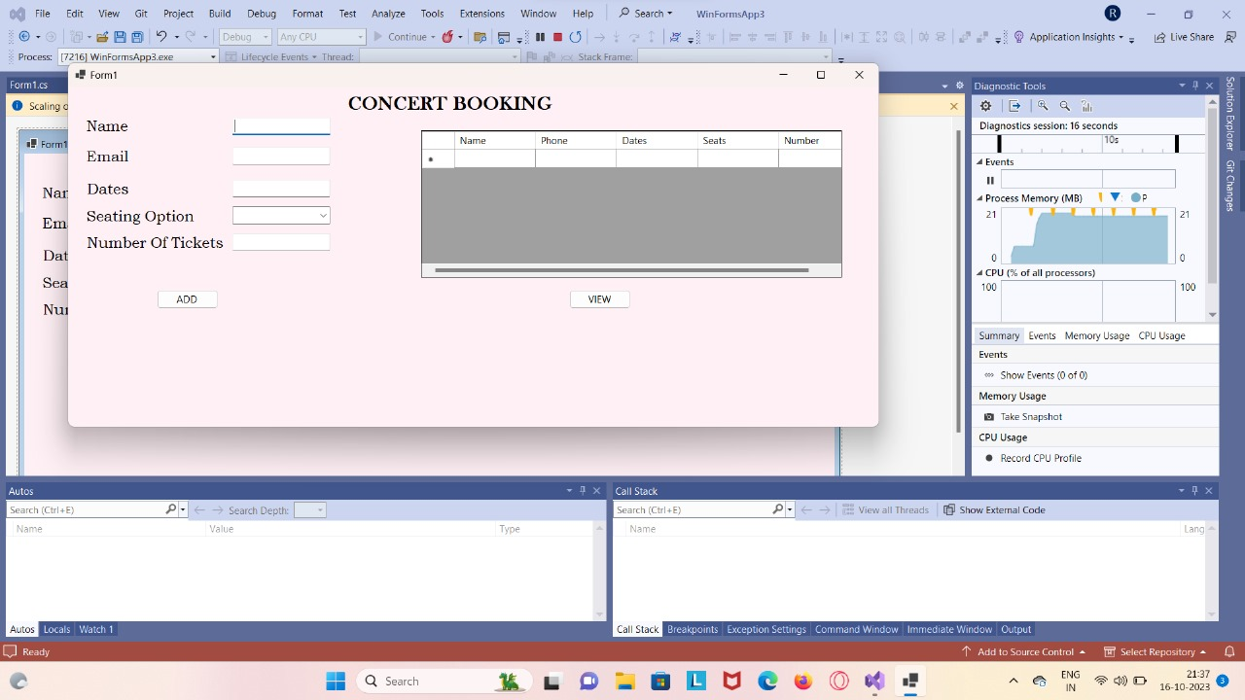

# 

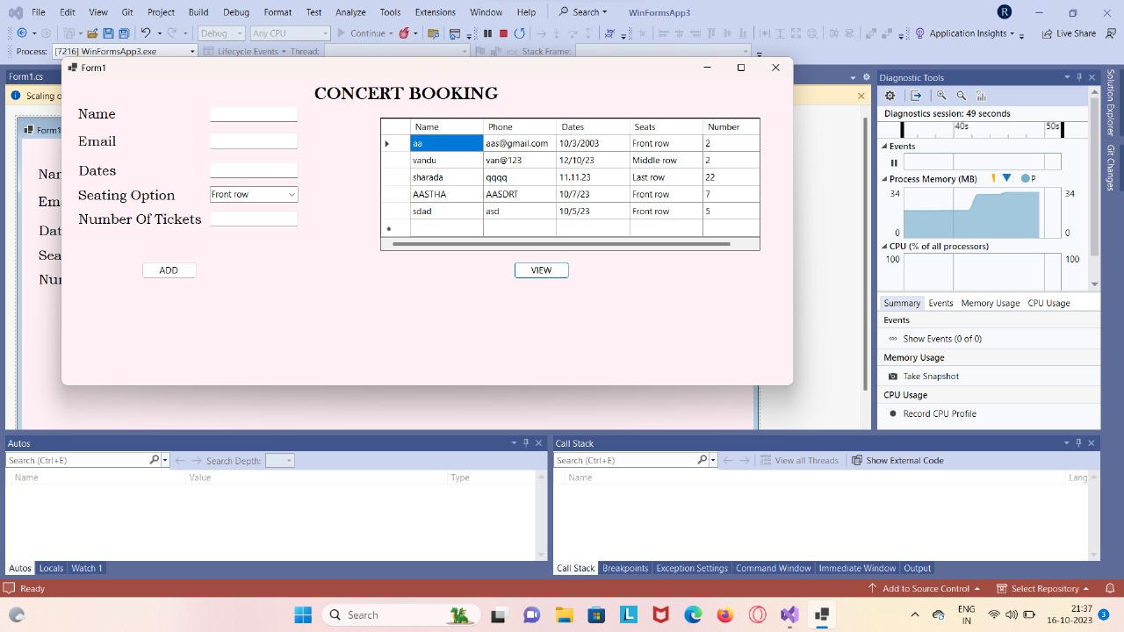

# 

# CODE

using MySql.Data.MySqlClient;

using System;

using System.Collections.Generic;

using System.ComponentModel;

using System.Data;

using System.Drawing;

using System.Linq;

using System.Text;

using System.Threading.Tasks;

using System.Windows.Forms;

namespace WinFormsApp3

{

public partial class Form1 : Form

{

public Form1()

{

InitializeComponent();

}

string sql;

MySqlDataReader read;

string str = "server=localhost; uid=root; pwd=Aastha@1978; database=concert";

private void button1_Click(object sender, EventArgs e)

{

MySqlConnection conn = new MySqlConnection(str);

conn.ConnectionString = str;

conn.Open();

sql = "insert into booking(name,email,Dates,seating_option,number_of_tickets) values(@name,@email,@Dates,@seating_option,@number_of_tickets)";

MySqlCommand cmd = new MySqlCommand(sql, conn);

cmd.Parameters.AddWithValue("@name", textBox1.Text);

cmd.Parameters.AddWithValue("@email", textBox2.Text);

cmd.Parameters.AddWithValue("@Dates", textBox3.Text);

cmd.Parameters.AddWithValue("@seating_option", comboBox1.Text);

cmd.Parameters.AddWithValue("@number_of_tickets", textBox4.Text);

MessageBox.Show("record added");

cmd.ExecuteNonQuery();

textBox1.Clear();

textBox2.Clear();

textBox3.Clear();

textBox4.Clear();

}

private void button2_Click(object sender, EventArgs e)

{

MySqlConnection conn = new MySqlConnection(str);

conn.ConnectionString = str;

conn.Open();

sql = "select * from booking";

MySqlCommand cmd = new MySqlCommand(sql, conn);

MySqlDataReader reader = cmd.ExecuteReader();

dataGridView1.Rows.Clear();

while (reader.Read())

{

dataGridView1.Rows.Add(reader[0], reader[1], reader[2], reader[3], reader[4]);

}

conn.Close();

}

private void dataGridView1_CellContentClick_1(object sender, DataGridViewCellEventArgs e)

{

}

}

}